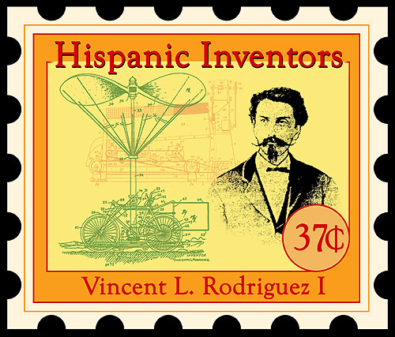

Computer Graphics

Stamp Art Project

Cultural Diversity / Minority Inventors

Lesson One

Situating the Lesson: This lesson is the first of two in this unit that will culminate in students creating stamps based on minority inventors using the Photoshop Computer Graphics program. During this lesson students will be introduced to the world of the internet and specifically the United States Patent Office as they research their chosen minority inventors. In the next lesson they will use information from their research online to create a stamp commemorating a minority inventor.

Assessment Work Product: A completed BDA form , An Essay on a minority inventor. Downloaded graphics from the internet.

California State Content Standards Addressed in this Unit: 3.0 Historical and Cultural Context

Objectives:
At the end of this lesson students will have shown the necessary internet navigation skills for completing the lesson assignment. Students will research minority inventors and patents on the internet. They will write a report on a minority inventor and have downloaded graphics of some of the inventions of this person. They will present a report of their inventor with illustrations to the entire class.

Materials Needed:
Computer Lab with access to the internet so as to access the United States Patent Office on the internet, and search engines such as Google, Alta Vista, and Yahoo.

Discipline Specific Vocabulary:

layers options
selection alignment
airbrush clone
cropping hue
thumbnail font
patent search engine
browser internet
graphic composition

Literacy Strategies:

Pre-reading literacy strategies: Students will write the dispatch in their journals in
Preparation to discussion. (see below)

Pre-reading Literacy strategies: Students will begin a ‘BDA’ form writing down
everything they know about inventors, inventions, and
the patent office before the lesson and going on the
internet.

Reading Literacy strategies: Students will write down everything they learn new
during the lesson and during their research on the
internet.

Post reading literacy strategies: Students will write a summary of the lesson and list
three questions about patents and/or inventors.

Writing Strategies: Students will write and present a report in class on
Minority inventor.

Dispatch: Write in Journals

“What makes America great is the diversity of our people, culture and ideas. As artists we should embrace this diversity and celebrate it in our art.”

Agenda:

1. Cultural Diversity is our strength
2. The Patent Process
3. Browsing the internet

Into Activity / Cultural Diversity

Leading up to this lesson, post on class bulletin boards posters and photos of minority painters, photographers, etc.

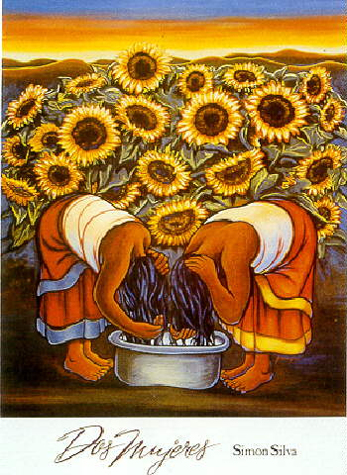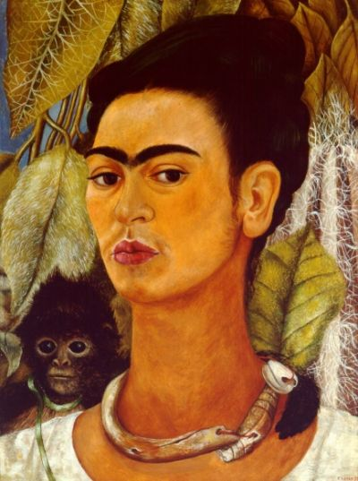

As a ‘Frontloading’ exercise, pass out a BDA form for students to begin filling out. They should begin by writing down everything they know or can think of regarding inventions, the patent office, and the internet. (This BDA format has three columns. The first column is for students to list what they know, the second is what they have learned by lecture or research and the third is for questions they have about the subject that might be answered in their research or in class.)

Explain and discuss with the class that it is the cultural diversity of our ‘American’ society that has made America the great country that it is and that in this lesson we are going to explore how minorities have contributed many of the inventions that have changed the way we live today.

Invite students to give examples of items around the school and in society that are from different cultures and backgrounds but that are now a part of our daily lives.

Through Activity / The Patent Process / Browsing the Internet

Using the Microsoft Powerpoint program on an overhead projector, present a prepared visual presentation on minority inventors at the U.S. Patent Office.

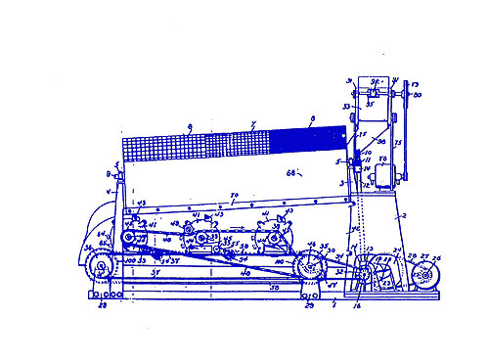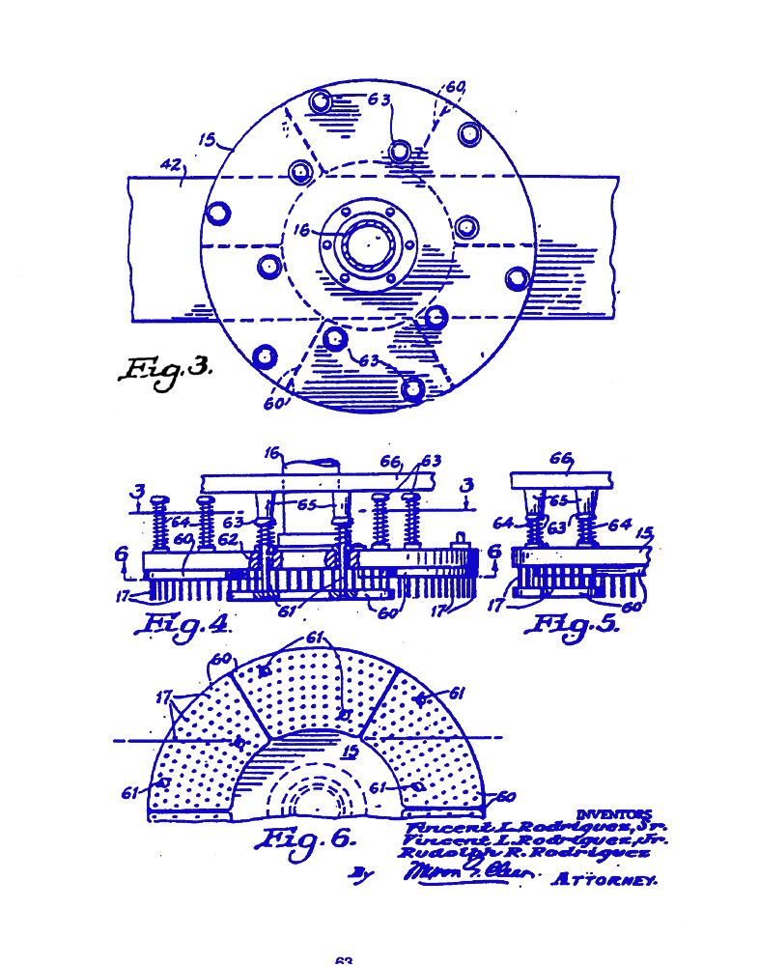

Example: The U.S. Patent Office, http://www.uspto.gov/, has hundreds of thousands of patents filed by minority inventors. These patents have greatly changed the way we live.

Example: Dr. Julio C. Palmaz is the inventor of the 'stent' that has revolutionized the heart surgery process. Where open heart surgery was almost always necessary before his invention, now it is a relatively simple outpatient procedure. Julio C. Palmaz is a doctor living in San Antonio, Texas, and is from Argentina.

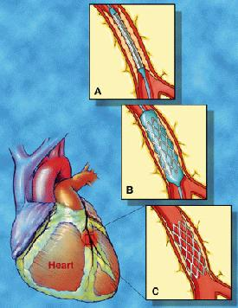

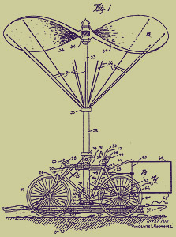
Example: Vincente Rodriguez I is the inventor of a flying machine declared top secret during WWI. It later became the prototype for helicopters. He also invented a machine for removing the shells off of pecans that revolutionized the pecan industry.

Browsing the Internet

Demonstrate to students using an LCD projector connected to a computer the methods for using search engines and browsing the internet. Be sure they are taking notes (Cornell Notes) and writing in their BDA sheets as new knowledge is acquired.

Point out the various search engines such as Google, Yahoo, and Altavista and how to refine their searches for specific topics.

Explain the method for navigating to the U.S. government patent office on the internet http://www.uspto.gov/.

Explain the process for searching for minority inventors at the U.S. Patent office.

Closing Activity : Summarize in BDA / Assign Homework

Students will summarize the lesson and write three questions in the final column of the BDA

Assign Homework:
In class (next class period) or at home students are to familiarize themselves with the U.S. Patent website http://www.uspto.gov/ paying particular attention to minority inventors and patents.

Based on their research, students will write a one page double spaced typed report on a minority inventor, telling about one invention and what it does and how it has changed our way of life. Students will be prepared to report on their inventor to the entire class.

Students will download graphics into their desktop folders that may be supportive of their reports and for use in the next Photoshop Lesson.

Sequence of Instructional Activities
Time | Teacher Procedures | Student Responsibilities
5 min.  10 min  35 min  10 min  Open  Class  Time  Next  Five Days | Dispatch  First Part BDA  Explain the Patent Process  Instruct the use of Search Engines and how to research topics on the internet.  Assess for learning.  Homework Assignment.  Review procedures  Turn computers over to students for  Research assignment | Write in Journals  Brainstorm in First Column of BDA what they know about patents, inventors.  Take notes, fill-in second column of BDA as new material is learned.  Summarize the lesson in BDA  Ask Questions if needed for clarity.  Write down homework assignment.  Check Notes and skills  Ask questions when necessary  Go online and research the assignment  Students write essay on Minority Inventor.

Evaluation: Assignment 1: BDA Form Points: 20

Assignment 2: One Page Report on
Minority inventor Points: 100
Download Graphics Points: 5 Points each
good graphic

Comments:

The purpose of this lesson is to research and prepare materials needed for students to design postage stamps commemorating minority inventors while learning features (layering) of the Photoshop program. But it has a dual purpose. In a student population that is 80 % minority it provides an opportunity to advance ethnic pride and make the subject matter more interesting and relevant to students’ daily lives.

It is very possible for students in today’s world to believe that only Caucasian types head corporations, become president of the United States, or are capable of inventing anything that is useful to society. The students during this lesson will disprove that notion and learn that many of the inventions that we take for granted today are the work of minority inventors. I have experienced students in my class who want to be called Joseph instead of Jose (for example) and I respect that. But I think it serves a better purpose to help make them aware that their culture should be a source of pride and that if they focus their learning and work hard they can accomplish great things.

The lesson addresses literacy through the opening content vocabulary, the BDA strategies, the computer research (multi-media and visual aids) and the written assignment. The students also have to deliver a report on their inventor to the entire class. (Not included in the time-line but should take one or two days.) This is an overlooked skill that is left undeveloped in many students today. It is hard enough to speak up in class, much less deliver a report in front of their peers. I have found that even 12th graders shy away from this and it is thus another form of literacy that needs to be practiced.

The students also practice academic rigor by deciding who to choose as a subject of their report and collect materials for their stamp projects. They are at the beginning concept stages for their big Photoshop project that comes up in the next lesson but they are making decisions that will set the course of the entire project. They are not given a concrete example that they can use. They are given an abstract and given the freedom to choose whom and what they will talk about. The only parameter is that it must be a minority inventor. I think getting students to ‘think’ for themselves and scaffold from one concept to another while completing an assignment represents real mastery of the subject content.

Computer Graphics Stamp Art Project

Cultural Diversity / Minority Inventors

Lesson Two

Layering in Photoshop

Situating the Lesson
This is the second of two lessons which will use the Fundamentals of Design, the Art Elements and skills learned in the Adobe Photoshop program to create stamp designs commemorating minority inventors.

California State Content Standards Addressed in this Unit: 1.0 Artistic Expression, 2.0 Creating, Performing and Participating in the Visual Arts, 3.0 Understand the Historical Contributions and Cultural Dimensions of the Visual Arts, 4.0 Responding to, Analyzing and Making Judgments About Works in the Visual Arts, 5.0 Connections, Relationships, Applications

Objective:
At the end of this lesson students will be able to use Photoshop to design their own stamps honoring minority inventors. They will be skilled in such features in Photoshop as selecting, layers, and using the Type Tool. They will use these features and others to design stamps arising from their own ideas and following a proper design structure.

Agenda

1. Review of the Photoshop Toolbox
2. Layers in Photoshop
3. Putting it all together in designing a stamp.

Into Activity / Review of the Photoshop Toolbox

With the use of an LCD projector attached to a computer review the basic features of the Photoshop tool box. These have been covered in previous weeks in detail. Give examples of the use of particular tools that will be used to create a stamp in this lesson.

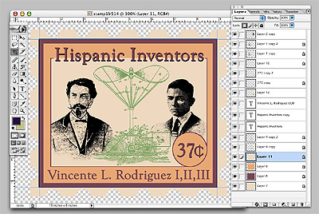

Through Activity / Layers in Photoshop

Pass out the handout which visually explains the different features of Layers in Photoshop.

Explain the features of Layers in Photoshop and demonstrate how the stamp example above is really a series of layers one on top of the other.

Explain the advantages of layers and demonstrate how colors and designs can be changed easily.

Features to demonstrate include: Masking, New Layers, Grouping in Folders, Special Effects, Merging, Linking, and Properties.

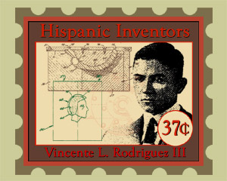

Closing Activity / Putting it all together to Design a Stamp

Demonstrate the process for designing a stamp from thumbnail, to final design. Show students how they can use the graphics they have collected (Homework) in their stamps for the inventors they have chosen.

Assess for learning.

Quiz students on how each feature works and which are how they may be used by them when creating their own stamps.

Assignment:

Students are to prepare thumbnail ideas (at least 4 variations) for their full size stamps. Each stamp should include a graphic of the inventor, the invention (or a patent drawing), or both.
The final version thumbnail must be approved before proceeding to the full size final.

Materials Needed:

Computers, Adobe Photoshop licensed program.

Assessment:

Students work (product) will be assessed as one according to the following Rubric:

 | A  100 points | B  85 points | C  75 points | D  65 points | F  0 points
Technology Skills | There is a strong and effective use of technology. Work is neat and orderly. | There is a good and effective use of technology. The work is neat and orderly. | There is some good use of technology skills. The work is mostly neat and orderly. | There are some technology skills. The work is somewhat neat and orderly. | Poor or no evidence of technology skills. Work is not neat or orderly.
Design Skills | There is a strong Evidence of the Fundamentals of Design | There is good evidence of the Fundamentals of Design. | There is some evidence of the Fundamentals of Design. | There is little evidence of the Fundamentals of Design. | There is little or no evidence of the Fundamentals of Design.
Creativity | The Student created an Original interpretation of the subject matter for the assignment. The work is aesthetically pleasing. | The student created a good interpretation of the subject matter for the assignment. The work is aesthetically pleasing. | The student created an interpretation of the subject matter for the assignment. The work is somewhat aesthetically pleasing. | The work is not original, and is only somewhat aesthetically pleasing. | The work is not original, or complete and lacks aesthetic value.
Communication Skills | The message is delivered in a clear, obvious and precise manner successfully. | The message is delivered clearly and is successful. | The message is delivered clearly but is only partly successful. | The message is not delivered clearly and is only partly successful. | The message is not communicated successfully.
Effort | The student has worked hard to fulfill the requirements of the assignment. The assignment is completed on time. | The student has worked well to fulfill the requirements of the assignment. The assignment is completed on time. | The student has put in little effort to meet the requirements of the assignment but the assignment is on time. | There is little obvious effort to work on assignment. The work is finally completed late. | There is no effort to work on the assignment and the assignment is not completed.

